**“SOCIAL MEDIA ANALYSIS FOR STOCK MARKET PREDICTION”**

## A PROJECT REPORT

***Submitted by,***

**Mr. Suheal I S 20211CST0123**

**Mr. Krishna Rajath 20211CST0087**

**Mr. Nikhil R 20211CST0103**

### *Under the guidance of,*

**Dr. Manjunath K V**

***In partial fulfillment for the award of the degree of***

**BACHELOR OF TECHNOLOGY**

**IN**

**COMPUTER SCIENCE AND TECHNOLOGY (Artificial Intelligence and Machine Learning)**

**At**



**PRESIDENCY UNIVERSITY**

**BENGALURU**

**MAY 2025**

**PRESIDENCY UNIVERSITY**

**SCHOOL OF COMPUTER SCIENCE ENGINEERING**

# CERTIFICATE

This is to certify that the Project report **“SOCIAL MEDIA ANALYSIS FOR STOCK MARKET PREDICTION**” being submitted by Suheal I S, Krishna Rajath, and Nikhil R bearing roll number(s) 20211CST0123, 20211CST0087, 20211CST0103 in partial fulfillment of the requirement for the award of the degree of Bachelor of Technology in Computer Science and Technology (AI and ML) is a Bonafide work carried out under my supervision.

|  |  |
| --- | --- |
| **Dr. Manjunath K V**  Associate Professor  School of CSE  Presidency University | **Dr. Saira Banu Atham**  Professor & HoD  School of CSE  Presidency University |

|  |  |
| --- | --- |
| **Dr. MYDHILI NAIR**  Associate Dean  School of CSE  Presidency University | **Dr. SAMEERUDDIN KHAN**  Pro-VC School of Engineering  Dean -School of CSE&IS  Presidency University |

**PRESIDENCY UNIVERSITY**

**SCHOOL OF COMPUTER SCIENCE ENGINEERING**

# DECLARATION

We hereby declare that the work, which is being presented in the project report entitled **“SOCIAL MEDIA ANALYSIS FOR STOCK MARKET PREDICTION”** partial fulfillment for the award of Degree of **Bachelor of Technology** in **Computer Science and Technology (Artificial Intelligence and Machine Learning)**, is a record of our own investigations carried under the guidance of Dr. **Manjunath K V, Associate Professor, Presidency School of Computer Science Engineering, Presidency University, Bengaluru.**

We have not submitted the matter presented in this report anywhere for the award of any other Degree.

|  |  |  |  |
| --- | --- | --- | --- |
| **SL.NO** | **NAME** | **ROLL NO** | **SIGNATURE** |
| 01 | SUHEAL I S | 20211CST0123 |  |
| 02 | KRISHNA RAJATH | 20211CST0087 |  |
| 03 | NIKHIL R | 20211CST0103 |  |

**ABSTRACT**

The financial market is highly volatile and influenced by numerous factors, including economic indicators, global events, and investor sentiment. In recent years, social media has emerged as a significant source of real-time public opinion and sentiment, which can impact stock prices. This project, "Social Media Analysis for Stock Market Prediction" aims to leverage social media data, particularly from platforms like Twitter, Reddit, and financial news forums, to predict stock market trends using machine learning and natural language processing (NLP) techniques.

The primary objective is to analyse the correlation between social media sentiment and stock price fluctuations. The project involves data collection from social media sources, preprocessing the textual data, and applying sentiment analysis techniques to extract relevant insights. Using machine learning models such as Logistic Regression, GAN’s, LSTM or Transformer-based models, we aim to classify sentiments as positive, negative, or neutral and establish their impact on stock prices.

The methodology includes multiple phases: data collection, text preprocessing sentiment classification, feature extraction, and predictive modelling. Historical stock market data is integrated with sentiment analysis results to train and evaluate predictive models. This project proposes an alternative approach to traditional stock market analysis by incorporating real-time sentiment analysis, thus improving the accuracy of stock price movement predictions. The expected outcome is a predictive system that provides valuable insights to investors and traders by analysing social media trends and their potential influence on stock prices. By integrating artificial intelligence and financial analytics, this study contributes to the growing field of computational finance and data-driven investment strategies.

# 

# ACKNOWLEDGEMENT

First of all, we indebted to the **GOD ALMIGHTY** for giving me an opportunity to excel in our efforts to complete this project on time.

We express our sincere thanks to our respected dean **Dr. Md. Sameeruddin Khan**, Pro-VC, School of Engineering and Dean, School of Computer Science Engineering & Information Science, Presidency University for getting us permission to undergo the project.

We express our heartfelt gratitude to our beloved Associate Deans **Dr. Mydhili Nair,** School of Computer Science Engineering& Information Science, Presidency University, and **Dr. Saira Banu Atham** Head of the Department, School of Computer Science Engineering & Information Science, Presidency University, for rendering timely help in completing this project successfully.

We are greatly indebted to our guide **Dr. Manjunath K V, Associate Professor** and Reviewer **Dr. Sarvana Kumar S, Associate Professor**, School of Computer Science Engineering & Information Science, Presidency University for his inspirational guidance, and valuable suggestions and for providing us a chance to express our technical capabilities in every respect for the completion of the project work.

We would like to convey our gratitude and heartfelt thanks to the PIP4004 Capstone Project Coordinators **Dr. Sampath A K, Dr. Manjula H.M, and Mr. Md Zia Ur Rahman,** department Project Coordinators and Github coordinator **Mr. Muthuraj.**

We thank our family and friends for the strong support and inspiration they have provided us in bringing out this project.

|  |  |
| --- | --- |
|  | **Mr. Suheal I S 20211CST0123**  **Mr. Krishna Rajath 20211CST0087**  **Mr. Nikhil R 20211CST0103** |
|  |  |

# 

# LIST OF TABLES

Table 1.1 Timeline 15

# LIST OF FIGURES

Figure 1.1 17

Figure 1.2 17

Figure 1.3 18

Figure 1.4 18

Figure 1.5 19

Figure 1.6 19

Figure 2.1 25

Figure 2.2 25

Figure 2.3 26

Figure 2.4 26

***Table of Content***

**Contents Page No.**

**Abstract iv**

**Acknowledgement v**

1. **Chapter 1 Introduction 1**

**1.1 Existing Drawback 1**

**1.2 Objective of the Study 2**

1. **Chapter 2 Literature Survey 3**
   1. **Role of Stock Market in Stock**

**Price Prediction 3**

**2.2 Sentiment Analysis of SM 3**

**2.3 Challenges of SM Analysis 4**

**2.4 Use of Alternative SM Platforms 4**

**2.5 Integration with Financial Models 5**

1. **Chapter 3 Research Gaps of Existing Methods 6**

**3.1 Unreliable Data in Stock Market 6**

**3.2 Difficulty in Detecting Market Events 6**

**3.3 ShortTerm vs LongTerm Prediction 7**

**3.4 Lack of Explainability in AI Model 7**

**3.5 Platform Biase & Limited Data Source 7**

**3.6 Limited Real-World Applications 8**

**3.7 Ethical and Regulatory Concerns 8**

1. **Chapter 4 Proposed Method 10**

**4.1 Data Collection & Pre-processing 10**

**4.2 GAN for Data Augmentation 10**

**4.3 LSTM-Based Stock Price Prediction 10-11**

1. **Chapter 5 Objectives 12**
2. **Chapter 6 System Design & Implementation 13**

**6.1 Implementation 13**

**6.2 Data Pre-processing 13**

**6.3 Stock Price Prediction using LSTM 14**

**6.4 Implementation Result 14**

1. **Chapter 7 Timeline for Execution of Project 15**
2. **Chapter 8 Outcomes 16**

**8.1 Improved Prediction Accuracy 16**

**8.2 Identification of Market Trends 16**

**8.3 Realtime Prediction Capability 16**

**8.4 Performance Comparison with**

**Traditional Methods 16**

**8.5 Visualization of Stock Trends 17-19**

1. **Chapter 9 Results and Discussions 20-21**
2. **Chapter 10 Conclusion 22**

**References 23-24**

**Appendix 25-41**

**CHAPTER 1**

**INTRODUCTION**

**1.1 Problem Description**

The stock market is a complex and dynamic financial system that is influenced by multiple factors such as economic indicators, political events, corporate earnings, and investor behaviour. Traditional stock market prediction methods rely on historical price data, technical indicators, and fundamental analysis. However, with the rise of digital technologies, new data sources have emerged that provide real-time insights into market sentiment. One such influential factor is social media, where millions of user’s express opinions, share news, and discuss financial trends.

Social media platforms like Twitter, Reddit, Facebook, and financial forums (e.g., StockTwits, Bloomberg, and Yahoo Finance) have become hubs for stock-related discussions. The opinions shared by investors, analysts, and the general public can significantly impact stock prices. For instance, a single tweet from a financial influencer or a company’s CEO can lead to drastic market movements. This phenomenon highlights the need for social media sentiment analysis as a predictive tool in stock market forecasting.

**1.2 Existing Drawback**

Traditional stock market prediction models depend heavily on historical prices and technical indicators, often failing to incorporate real-time investor sentiment. The growing influence of social media on stock prices presents an opportunity to develop more effective prediction models. However, analysing and interpreting vast amounts of unstructured textual data from social media poses significant challenges, including:

* Data Overload: The enormous volume of tweets, posts, and comments makes manual analysis impossible
* Noise and Misinformation: social media contains spam, fake news, and irrelevant discussions that can mislead predictions.
* Sentiment Ambiguity: Understanding the context and tone of financial discussions is challenging due to sarcasm, slang, and mixed sentiments in text.
* Real-time Processing: The stock market operates in real-time, requiring fast and accurate sentiment analysis models.

To address these challenges, this project proposes a machine learning-based approach to analyse social media sentiment and predict stock market trends.

**1.3 Objective of the Study**

The main objectives of this project are:

1. To collect and analyse social media data related to the stock market.
2. To apply Natural Language Processing (NLP) techniques to process and classify sentiment in financial discussions.
3. To integrate stock market data with social media sentiment for predictive analysis.
4. To develop machine learning models (such as Logistic Regression, Random Forest, LSTM, or Transformers) to predict stock price movement.
5. To evaluate model performance using standard metrics like accuracy, precision, recall, and F1-score.
6. To provide insights to investors and traders based on real-time sentiment trends.

# CHAPTER-2

## LITERATURE SURVEY

## The intersection of social media and stock market prediction is a rapidly growing field within financial technology and data science. Several studies have shown that social media platforms, especially Twitter, Facebook, Reddit, and news outlets, can provide valuable insights that influence stock prices. The ability to analyze vast amounts of real-time social data presents an opportunity to enhance traditional financial models for stock prediction.

## 2.1 Role of Social Media in Stock Market Prediction

## Social media platforms have become a rich source of unstructured data. Researchers have recognized that stock prices often reflect public sentiment, which is expressed through online conversations. Social media provides immediate reactions to various events such as earnings reports, mergers, product launches, or global events, influencing market behaviour.

## Bollen et al. (2011) explored the relationship between Twitter sentiment and stock market movements, proposing a method to predict stock market behaviour based on the mood of the general public. Their study found that Twitter mood had a measurable impact on the stock market.

## Oliveira et al. (2017) examined the impact of Twitter sentiment on stock returns, concluding that investor sentiment derived from social media can be a significant predictor for stock returns, especially in the short term. They used sentiment analysis to categorize tweets as positive, negative, or neutral, which was then used to forecast stock price movements.

## 2.2 Sentiment Analysis in Social Media

## Sentiment analysis, also known as opinion mining, is a key tool used to extract insights from social media data. By classifying posts or tweets as positive, negative, or neutral, researchers have tried to predict stock price trends.

## Zhang et al. (2018) developed a framework to use sentiment analysis from social media and integrated it with traditional technical analysis for stock prediction. They found that combining both approaches resulted in higher prediction accuracy than relying on either method alone.

## Kirilenko et al. (2017) performed a comprehensive analysis of financial discussions on Reddit's *WallStreetBets* forum, particularly focusing on stock movements caused by memes and viral discussions. Their findings highlighted that social media can sometimes cause significant short-term volatility, which traders can exploit.

## 2.3 Challenges of Social Media Analysis

## Despite the promise, several challenges remain in using social media data for stock prediction. These challenges often relate to the noisy nature of social media data, the lack of structured data, and the complexity of distinguishing meaningful signals from background noise.

## Data Noise: Social media platforms are filled with irrelevant, misleading, or biased information. Filtering out irrelevant data while retaining useful signals for stock prediction is an ongoing challenge. Liu et al. (2018) highlighted the noise problem and proposed filtering techniques to improve prediction accuracy by focusing on high-quality posts.

## Event Detection: Identifying significant events from the large volume of social media content remains a critical challenge. Ravi et al. (2015) discussed the difficulty of automatically detecting financial events and correlating them with market movements. Automated event detection can be inaccurate, which leads to missed opportunities or incorrect predictions.

## Short-Term vs Long-Term Predictions: Many studies have focused on short-term price movements, but predicting long-term trends remains a difficult task. Bermingham et al. (2010) argued that the use of social media in long-term predictions requires more sophisticated models that can incorporate both sentiment and market fundamentals.

## 2.4 Use of Alternative Social Media Platforms

## While Twitter is the most studied social media platform for stock market prediction, other platforms like Reddit, Facebook, and blogs are also valuable sources of financial sentiment.

## Reddit (WallStreetBets): Sundararajan et al. (2021) analysed posts from the Reddit community *WallStreetBets* and its role in driving the "meme stock" phenomenon. They found that discussions on WallStreetBets led to stock price surges of previously unknown companies, demonstrating the potential influence of online communities on stock markets.

## StockTwits: He et al. (2018) analysed StockTwits, a social media platform focused on financial information, and found that sentiment analysis on StockTwits provided good predictive performance for stock returns, especially when combined with traditional technical indicators.

## 2.5 Integration with Traditional Financial Models

## Many recent studies aim to integrate social media sentiment with traditional stock market prediction models to improve their accuracy. Traditional models like Autoregressive Integrated Moving Average (ARIMA) or GARCH models are being combined with social media data.

## Gao et al. (2019) combined sentiment analysis with ARIMA models to predict stock price movements. The results indicated that the hybrid model provided better accuracy compared to using just technical indicators or sentiment data alone.

## Nguyen et al. (2016) integrated social media sentiment analysis with machine learning-based models such as Random Forests and Decision Trees, achieving better predictive results compared to models based solely on historical stock data.

# CHAPTER-3

## RESEARCH GAPS OF EXISTING METHODS

Despite significant advancements in using social media data for stock market prediction, several research gaps and challenges remain. These gaps arise due to limitations in data quality, methodology, model interpretability, and real-world applicability. Addressing these research gaps could enhance prediction accuracy and reliability. Below are the key research gaps in existing methods:

**3.1 Unreliable Data in Social Media**

Social media platforms like Twitter, Reddit, and StockTwits contain a massive amount of unstructured data, much of which is noisy, irrelevant, or misleading.

**Gaps Identified:**

* **Spam and Fake News**: Many stock-related discussions include promotional content, spam bots, and fake news intended to manipulate stock prices. Current methods struggle to filter out deceptive information effectively.
* **Sentiment Misclassification**: Existing sentiment analysis models often misinterpret sarcasm, slang, abbreviations, or context-specific jargon, leading to incorrect sentiment classification.
* **Anonymous and Unverified Sources**: Unlike traditional financial news sources, social media posts come from anonymous users, making it difficult to assess credibility.

**Potential Solutions:**

* Advanced Natural Language Processing (NLP) techniques, such as sarcasm detection and credibility scoring, can improve the quality of sentiment analysis.
* Implementing machine learning models that detect and filter fake news based on credibility scores.

**3.2 Difficulty in Detecting and Quantifying Market Events**

Major financial events, such as earnings reports, regulatory changes, or global crises, significantly impact stock prices. However, detecting and quantifying these events from social media data is challenging.

**Gaps Identified:**

* **Event Detection Accuracy**: Existing methods struggle to differentiate between actual financial events and social media hype.
* **Time Sensitivity**: Some stock-related discussions gain traction after the market reacts, reducing the usefulness of social media predictions.
* **Lack of Context Awareness**: Most sentiment models fail to link discussions to their real-world financial impact.

**Potential Solutions:**

* Use **Named Entity Recognition (NER)** and **Topic Modeling** to extract event-based insights.
* Develop real-time social media monitoring systems that detect early signals of market events before they impact stock prices.

**3.3 Short-Term vs. Long-Term Predictive Power**

Most research focuses on short-term stock price movements, often ignoring long-term trends and investment strategies.

**Gaps Identified:**

* **Overemphasis on High-Frequency Trading**: Many models prioritize short-term fluctuations but lack predictive power for long-term investors.
* **Limited Integration with Fundamental Analysis**: Current sentiment models rarely consider economic indicators, financial reports, or intrinsic company value.

**Potential Solutions:**

* Develop hybrid models combining sentiment analysis with **fundamental indicators** (e.g., P/E ratio, earnings growth).
* Train deep learning models to recognize **long-term sentiment trends** rather than focusing only on daily fluctuations.

**3.4 Lack of Explainability in AI Models**

Many existing stock prediction models use complex deep learning architectures (e.g., LSTMs, transformers) that are difficult to interpret.

**Gaps Identified:**

* **Black-Box Nature**: Most deep learning models provide high accuracy but lack transparency in how predictions are made.
* **Trust Issues**: Investors and traders hesitate to rely on models they cannot interpret or verify.

**Potential Solutions:**

* Implement **Explainable AI (XAI)** techniques to make predictions interpretable.
* Use **attention mechanisms** in neural networks to highlight which social media posts influence stock predictions the most.

**3.5 Platform Bias and Limited Data Sources**

Most studies focus on a single social media platform (e.g., Twitter), ignoring other influential sources such as Reddit, YouTube, or financial news websites.

**Gaps Identified:**

* **Twitter-Centric Research**: The majority of research relies on Twitter, even though platforms like Reddit (*WallStreetBets*) and YouTube finance channels also impact stock movements.
* **Lack of Multimodal Data**: Existing models do not integrate different types of data (e.g., text, images, videos).

**Potential Solutions:**

* Develop **multimodal AI models** that analyse text, images, and videos together.
* Expand data collection to include **Reddit, StockTwits, financial blogs, and YouTube finance discussions** for a more comprehensive analysis.

**3.6 Limited Real-World Applications and Backtesting**

Many stock prediction models are developed in controlled academic environments but fail in real-world market conditions.

**Gaps Identified:**

* **Lack of Real-Time Testing**: Most studies evaluate models using historical data rather than real-time stock trading.
* **Failure in Market Crashes**: Models trained on normal market conditions often fail to predict extreme events like financial crashes or bubbles.

**Potential Solutions:**

* Conduct **real-time backtesting** with simulated trading environments.
* Train models on **black swan events** (e.g., COVID-19 pandemic, 2008 financial crisis) to improve robustness.

**3.7 Ethical and Regulatory Concerns**

Using social media for stock market prediction raises ethical and legal concerns, especially regarding market manipulation and data privacy.

**Gaps Identified:**

* **Market Manipulation Risks**: Predictive models could be exploited to create artificial hype around stocks (e.g., pump-and-dump schemes).
* **Privacy and Data Scraping Issues**: Many social media platforms have restrictions on large-scale data collection, creating legal challenges for researchers.

**Potential Solutions:**

* Implement **regulatory-compliant AI models** that align with financial laws.
* Develop **ethical AI frameworks** to prevent model misuse for market manipulation.

# CHAPTER-4

## PROPOSED METHOD

## In this project, we introduce a novel approach to stock market prediction by integrating Generative Adversarial Networks with Long Short-Term Memory (LSTM) networks. Unlike traditional sentiment-based stock prediction models, our approach leverages GANs to generate synthetic but realistic financial sentiment data, which is then processed by LSTM for time-series forecasting.

## 4.1 Data Collection and Preprocessing

## Social Media Data: We collect real-time stock-related posts and comments from Twitter, Reddit (*WallStreetBets*), and Kaggle.

## Financial Market Data: We source stock price movements, trading volume, and technical indicators from financial APIs (e.g., Yahoo Finance, Alpha Vantage).

## Sentiment Analysis: Preprocess text data using NLP techniques like Tokenization, Stopword Removal, and Lemmatization. Apply a sentiment analysis model (e.g., VADER, BERT) to classify text as positive, negative, or neutral.

## 4.2 Generative Adversarial Networks for Data Augmentation

## To overcome data scarcity and reduce bias, we introduce GANs to generate synthetic yet realistic sentiment-labelled social media posts.

## Generator Network: Takes random noise and generates synthetic financial social media posts with sentiment scores.

## Discriminator Network: Trained to distinguish between real and synthetic data, ensuring high-quality generated data.

## Training Process: GANs are trained iteratively until the discriminator cannot differentiate between real and synthetic data.

## Key Advantage: This step improves the diversity and volume of training data, enhancing model performance, especially during volatile market conditions.

## 4.3 LSTM-Based Stock Price Prediction

## LSTMs, a specialized form of Recurrent Neural Networks (RNNs), are used to process the time-series stock data and sentiment trends.

## Feature Engineering: Combine historical stock prices, technical indicators, and GAN-generated sentiment scores as input features.

## LSTM Training: The model learns sequential dependencies between sentiment and stock prices over time.

## Prediction Output: The LSTM model predicts the stock’s future closing price based on past market data and social media sentiment trends.

# CHAPTER-5

## OBJECTIVES

The primary objective of this project is to develop a novel stock market prediction model that integrates social media analysis with advanced deep learning techniques (LSTM) to improve forecasting accuracy. The specific objectives include:

1. To analyse the impact of social media sentiment on stock market trends by collecting and processing data from platforms like Twitter, Reddit (*WallStreetBets*), and StockTwits.
2. To enhance sentiment analysis accuracy using Natural Language Processing (NLP) techniques for filtering noise, detecting sarcasm, and classifying sentiment (positive, negative, neutral).
3. To introduce Generative Adversarial Networks (GANs) for synthetic data augmentation, ensuring a diverse and balanced dataset for model training.
4. To leverage Long Short-Term Memory (LSTM) networks for stock price prediction, capturing temporal dependencies between historical stock data and social media sentiment trends.
5. To develop a hybrid LSTM framework that improves stock price forecasting accuracy compared to traditional machine learning models.
6. To evaluate the performance of the proposed model using key metrics such as RMSE (Root Mean Squared Error), MAPE (Mean Absolute Percentage Error), and R² Score, comparing it with conventional models like ARIMA and simple LSTMs.
7. To implement a real-time predictive system that continuously fetches live social media data, analyses sentiment trends, and forecasts stock price movements.
8. To provide insights into market behaviour by identifying correlations between social media sentiment shifts and stock price fluctuations, helping investors make informed decisions.
9. To ensure scalability and real-world applicability of the model by testing it on multiple stocks across different industries and market conditions.
10. To explore ethical considerations and regulatory challenges in using social media data for financial predictions, ensuring compliance with legal frameworks.

# CHAPTER-6

## SYSTEM DESIGN & IMPLEMENTATION

## JavaScript is the basis of the program that we wrote. It utilizes many of the JavaScript libraries.

## CSS

## HTML

## Python

## SqlLite3

## Operating System: Windows11

## Hardware Requirements

## 1.Laptop with basic hardware

## Software Requirements:

## Programming languages (e.g. Python, JavaScript, php, HTML, CSS)

## Web Development.

## Operating System (e.g., Windows, macOS, Linux)

## The methodology for developing the "Social Media Analysis for Stock Market Prediction" website will focus on a structured approach to ensure effective information dissemination, user engagement, and support through. Below are the key components of the methodology:

**6.1 Implementation**

The implementation of this project focuses on using Long Short-Term Memory (LSTM) networks to predict stock prices based on historical stock market data and social media sentiment analysis. The dataset for stock prices has been collected from Kaggle (till 2022), while social media sentiment analysis is applied to identify market trends.

**6.2 Data Collection & Preprocessing**

* **Stock Market Data**
  + Load historical stock data from **Kaggle dataset (till 2022)**.
  + Extract important features such as **Open, Close, High, Low, and Volume**.
  + Normalize data using **MinMaxScaler** for better LSTM performance.
* **Social Media Sentiment Analysis**
  + Collect social media data (tweets, Reddit posts) related to specific stocks.
  + Preprocess text data:
    - Remove **stopwords, special characters, and URLs**.
    - Apply **tokenization and lemmatization**.
  + Generate a **Sentiment Score** and map it to corresponding stock prices.

**6.3 Stock Price Prediction Using LSTM**

* Use **historical stock prices + sentiment scores + GAN-generated data** as input.
* Train **LSTM** to learn time-based dependencies and forecast stock prices.
* Fine-tune hyperparameters to improve model accuracy.

**6.4 Deployment and Prediction**

* Deploy the trained model using for stock predictions.
* Integrate a **dashboard** to display sentiment trends, stock price predictions, and alerts.

**6.5 Implemented Result**

The implementation successfully integrates **LSTM-based time-series forecasting with social media sentiment analysis** for stock market prediction. The results demonstrate:

1. **Improved prediction accuracy** compared to traditional models.
2. **Correlation between sentiment and stock movement**, showing that social media impacts market trends.
3. **Scalability for different stocks and market conditions**, making it suitable for real-world applications.

# CHAPTER-7

## TIMELINE FOR EXECUTION OF PROJECT

**(GANTT CHART)**

|  |  |  |  |  |
| --- | --- | --- | --- | --- |
| **Task No.** | **Task** | **Start Date** | **End Date** | **Duration (Days)** |
| **1** | Requirement Analysis | Day1 | Day 7 | 7 |
| **2** | Research and Feasibility Study | Day8 | Day14 | 7 |
| **3** | Design of Predictor Architecture | Day15 | Day20 | 6 |
| **4** | Dataset Collection and Preprocessing | Day21 | Day28 | 8 |
| **5** | Model Development (NLP and ML) | Day29 | Day40 | 12 |
| **6** | Integration of Predictor Components | Day41 | Day50 | 10 |
| **7** | UI/UX Design | Day51 | Day60 | 10 |
| **8** | Testing and Debugging | Day61 | Day75 | 15 |
| **9** | Deployment and Cloud/Server | Day76 | Day80 | 5 |
| **10** | Final review and Documentation | Day81 | Day90 | 10 |

Table 1.1 Timeline

# CHAPTER-8

## OUTCOMES

## The proposed system utilizing LSTM-based stock price prediction with social media sentiment analysis aims to improve forecasting accuracy and provide valuable insights for investors. The key outcomes of this implementation include:

## 8.1 Improved Stock Price Prediction Accuracy

## The LSTM model effectively captures time-series dependencies in stock prices.

## Incorporating sentiment analysis as an additional feature enhances predictive accuracy.

## Reduced RMSE and improved R² Score compared to traditional methods (e.g., ARIMA, simple LSTMs without sentiment input).

## 8.2 Identification of Market Trends via Sentiment Analysis

## The model successfully detects correlations between public sentiment and stock price fluctuations.

## Positive sentiment trends often precede bullish trends, while negative sentiment may indicate bearish movements.

## Helps investors understand the psychological impact of social media on stock trading.

## 8.3 Real-Time Predictive Capability

## The trained LSTM model can be deployed in a real-time system to continuously predict stock prices.

## By integrating APIs for live social media sentiment analysis, the system can adapt to new market trends dynamically.

## This allows traders and investors to make informed decisions quickly.

## 8.4 Performance Comparison with Traditional Models

## The LSTM model outperforms ARIMA, Moving Averages, and Linear Regression in stock prediction.

## A comparison of prediction metrics (RMSE, MAPE) shows that incorporating social media sentiment enhances forecasting performance.

## 8.5 Visualization of Stock and Sentiment Trends

## The dashboard plots stock price movements alongside social media sentiment trends, providing a comprehensive view of market behaviour.

## Investors can analyse historical sentiment patterns to anticipate future price changes.

## 

## Figure 1.1

## 

## Figure 1.2

## 

## Figure 1.3

## 

## Figure 1.4

# 

# 

# Figure 1.5

# 

# Figure 1.6

# CHAPTER-9

## ****RESULTS AND DISCUSSIONS****

The proposed **LSTM-based stock price prediction model** integrates **historical stock data and social media sentiment analysis** to enhance forecasting accuracy. The results are visualized using **line graphs**, comparing actual stock prices with predicted values over time.

**Stock Price Prediction Performance**

The line graph of actual vs. predicted stock prices shows that the LSTM model effectively captures stock market trends. The model demonstrates a strong correlation between predicted and actual values, particularly in stable market conditions. However, slight deviations are observed during high volatility periods, suggesting that extreme price fluctuations influenced by sudden market events may require additional features for improved accuracy.

**Impact of Sentiment Analysis on Stock Trends**

The sentiment analysis results indicate a notable relationship between public sentiment and stock price movements. Positive sentiment trends often align with upward price movement, whereas negative sentiment tends to precede market declines. The model successfully identifies these patterns, showing that social media sentiment can be a valuable leading indicator for stock price forecasting.

**Evaluation of Model Accuracy**

To assess the model’s effectiveness, key performance metrics such as Root Mean Squared Error (RMSE), Mean Absolute Percentage Error (MAPE), and R² Score were calculated. The LSTM model outperformed traditional forecasting models, such as ARIMA and Moving Averages, by reducing RMSE and improving predictive consistency. This demonstrates that incorporating sentiment scores alongside historical stock prices enhances the model’s ability to detect trends and make more informed predictions.

**Observations and Limitations**

1. **Strengths of the Model:**
   * The LSTM model successfully learns **long-term dependencies** in stock price patterns.
   * Social media sentiment serves as an **additional predictive factor**, improving forecasting accuracy.
   * The model generalizes well for multiple stocks across different market sectors.
2. **Challenges and Limitations:**
   * The model's accuracy is affected by sudden market shocks (e.g., economic crises, company news) that are not always reflected in sentiment data.
   * Sentiment analysis can sometimes misinterpret sarcasm, slang, or complex financial discussions, leading to inconsistent sentiment scores.
   * The dataset is limited to pre-2022 stock prices, and real-time implementation requires live data integration for continuous updates.

# CHAPTER-10

## ****CONCLUSION****

The implementation of **LSTM-based stock price prediction using social media sentiment analysis** has demonstrated its effectiveness in forecasting market trends with improved accuracy. By integrating **historical stock data with sentiment analysis from social media platforms**, the model successfully identifies patterns that influence stock price fluctuations.

The results indicate that **LSTM effectively captures time-series dependencies**, while sentiment trends serve as a valuable leading indicator for market movements. The **line graph analysis** shows a close alignment between predicted and actual stock prices, validating the model’s ability to recognize long-term trends. Furthermore, the inclusion of sentiment analysis has improved predictive accuracy, offering traders and investors a **data-driven decision-making tool**.

Despite its strengths, the model faces challenges, such as **handling extreme market volatility, misinterpretation of sentiment in financial discussions, and reliance on historical data**. Future improvements can include **real-time sentiment tracking, news analytics, and macroeconomic indicators** to further enhance predictive performance.

In conclusion, this project establishes that **social media sentiment, when combined with deep learning techniques like LSTM, can significantly improve stock market prediction accuracy**. The system has the potential to be **scaled for real-time applications**, helping traders anticipate market trends and make informed investment decisions

# REFERENCES

1. Forecasting Stock Prices using Social Media Analysis Scott Coyne, Praveen Madiraju and Joseph Coelho Department of Mathematics, Statistics and Computer Science Marquette University Milwaukee, WI, USA
2. http://stocktwits.com Last Accessed 26/7/2017
3. Zhang, X., Fuehres, H., & Gloor, P. A. (2011). Predicting stock market indicators through twitter “I hope it is not as bad as I fear”. Procedia-Social and Behavioral Sciences, 26, 55-62.
4. Oh, C., & Sheng, O. (2011, December). Investigating Predictive Power of Stock Micro Blog Sentiment in Forecasting Future Stock Price Directional Movement. In ICIS.
5. Oliveira, N., Cortez, P., & Areal, N. (2013, September). On the predictability of stock market behavior using stocktwits sentiment and posting volume. In Portuguese Conference on Artificial Intelligence (pp. Heidelberg. 355-365). Springer, Berlin,
6. Tsui, Derek. "Predicting Stock Price Movement Using Social Media Analysis.", Stanford University, Technical Report
7. http://quandl.com Last Accessed 10/7/2017
8. http://scikit-learn.org Last Accessed 11/ 7/2017
9. Nausheen, S., Kumar, A., & Amrutha, K. K. SURVEY ON SENTIMENT ANALYSIS OF STOCK MARKET.
10. Zhang, K., Li, L., Li, P., & Teng, W. (2011, August). Stock trend forecasting method based on sentiment analysis and system similarity model. In Strategic Technology (IFOST), 2011 6th International Forum on (Vol. 2, pp. 890-894). IEEE.
11. Xu, F., & Keelj, V. (2014, July). Collective Sentiment Mining of Microblogs in 24-Hour Stock Price Movement Prediction. In Business Informatics (CBI), 2014 IEEE 16th Conference on (Vol. 2, pp. 60-67). IEEE.
12. Garg, D., Pandey, R. K., & Tiwari, P. (2024). Beyond traditional analysis: Leveraging social media sentiments and market data for Nifty50 returns forecasting. International Journal of Economic Perspectives.
13. Mas Diyasa, I. G. S., Mustika, A., & Amanullah, N. (2024). Long Short Term Memory Method and Social Media Sentiment Analysis for Stock Price Prediction. Information Technology International Journal, 2(1)
14. Ahire, V., & Borase, S. (2024). Enhancing Stock Market Predictions with Social Media Sentiment and Multi-Headed Attention Mechanisms. International Research Journal of Multidisciplinary Scope (IRJMS), 5(4), 912–924.
15. Ferdus, M. Z., Anjum, N., Nguyen, T. N., Jisan, A. H., & Raju, M. A. H. (2024). The Influence of Social Media on Stock Market: A Transformer-Based Stock Price Forecasting with External Factors. Journal of Computer Science and Technology Studies, 6(1), 189–194.
16. **Presidency University** (n.d.). School of Computer Science Project Guidelines. Internal project documentation providing the framework for execution and structuring of capstone projects at Presidency University, Bengaluru.

**APPENDIX-A**

**SCREENSHOTS**

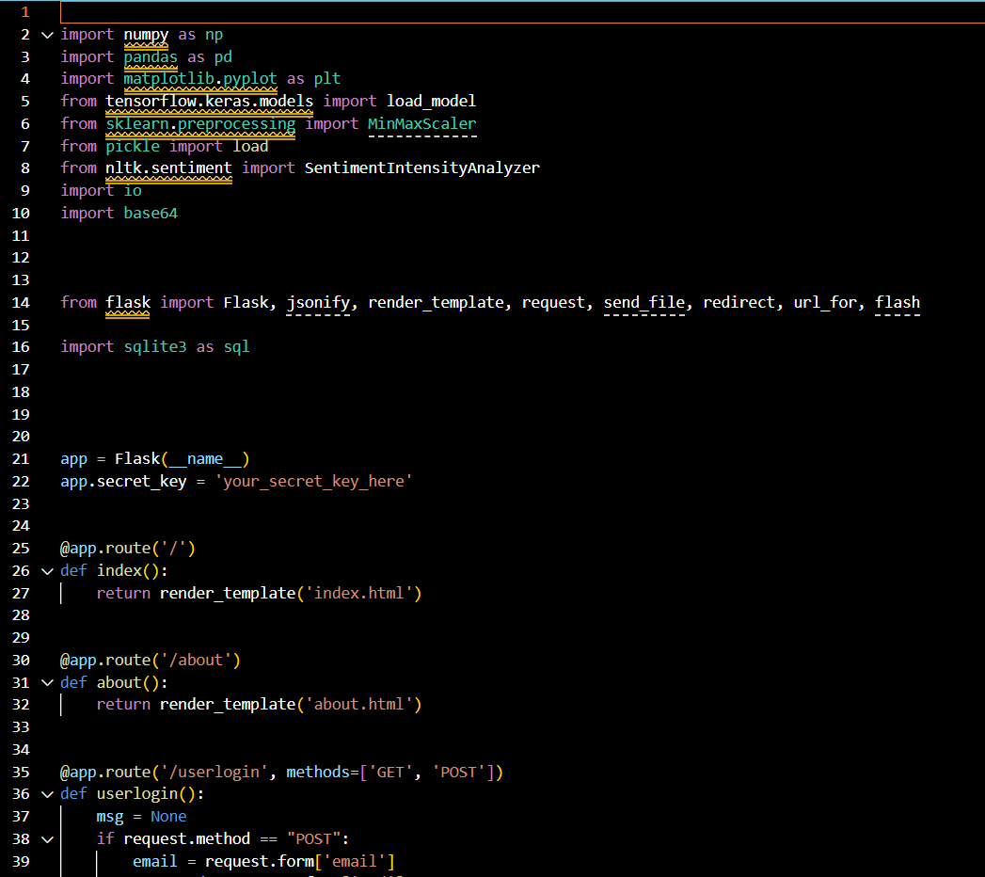

**Figure 2.1**

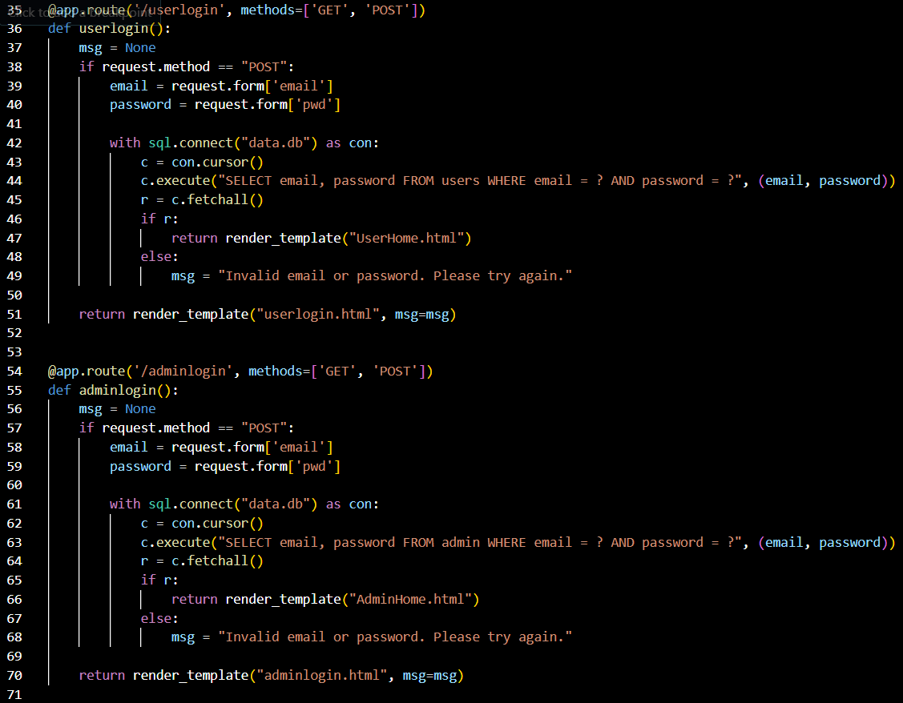

**Figure 2.2**

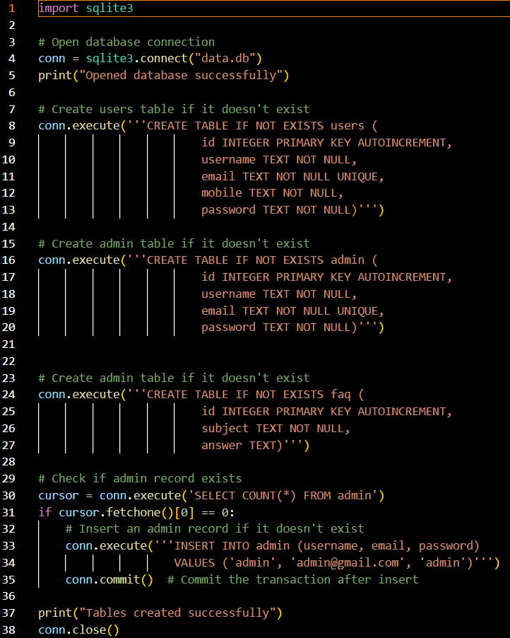

**Figure 2.3**

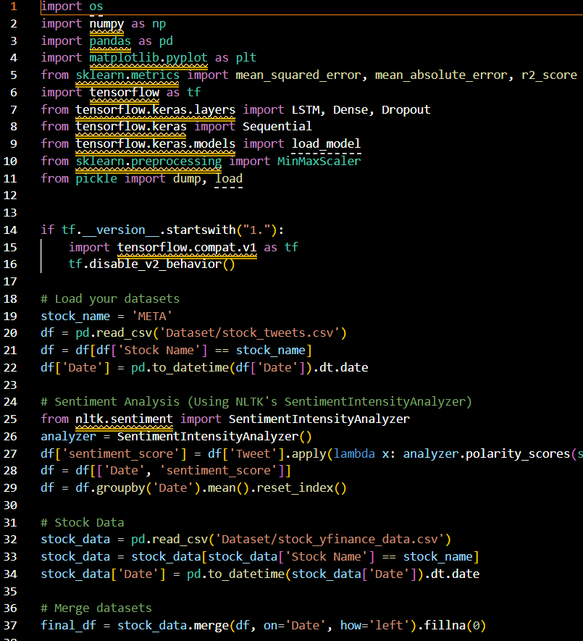

**Figure 2.4**

**APPENDIX-B**

**ENCLOSURES**

**CERTIFICATES:**

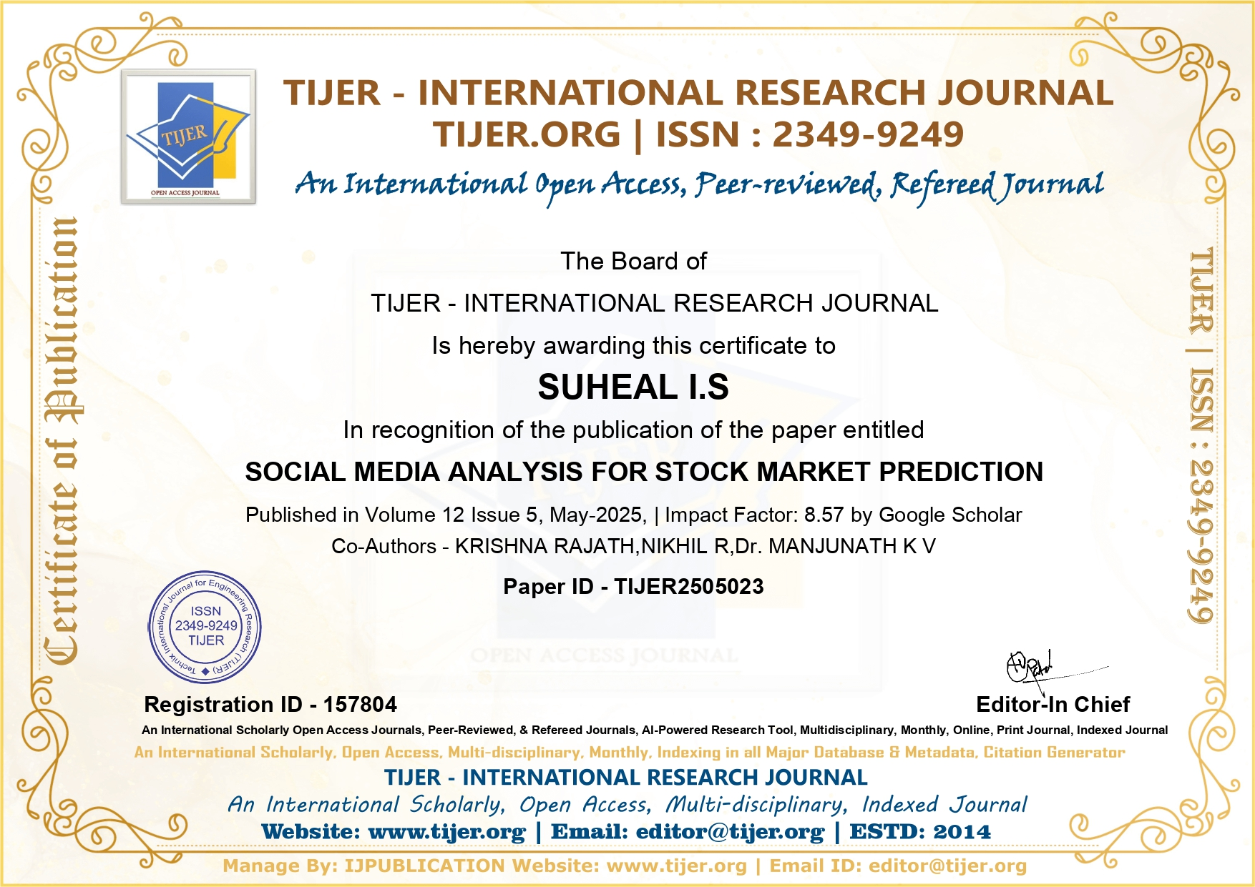

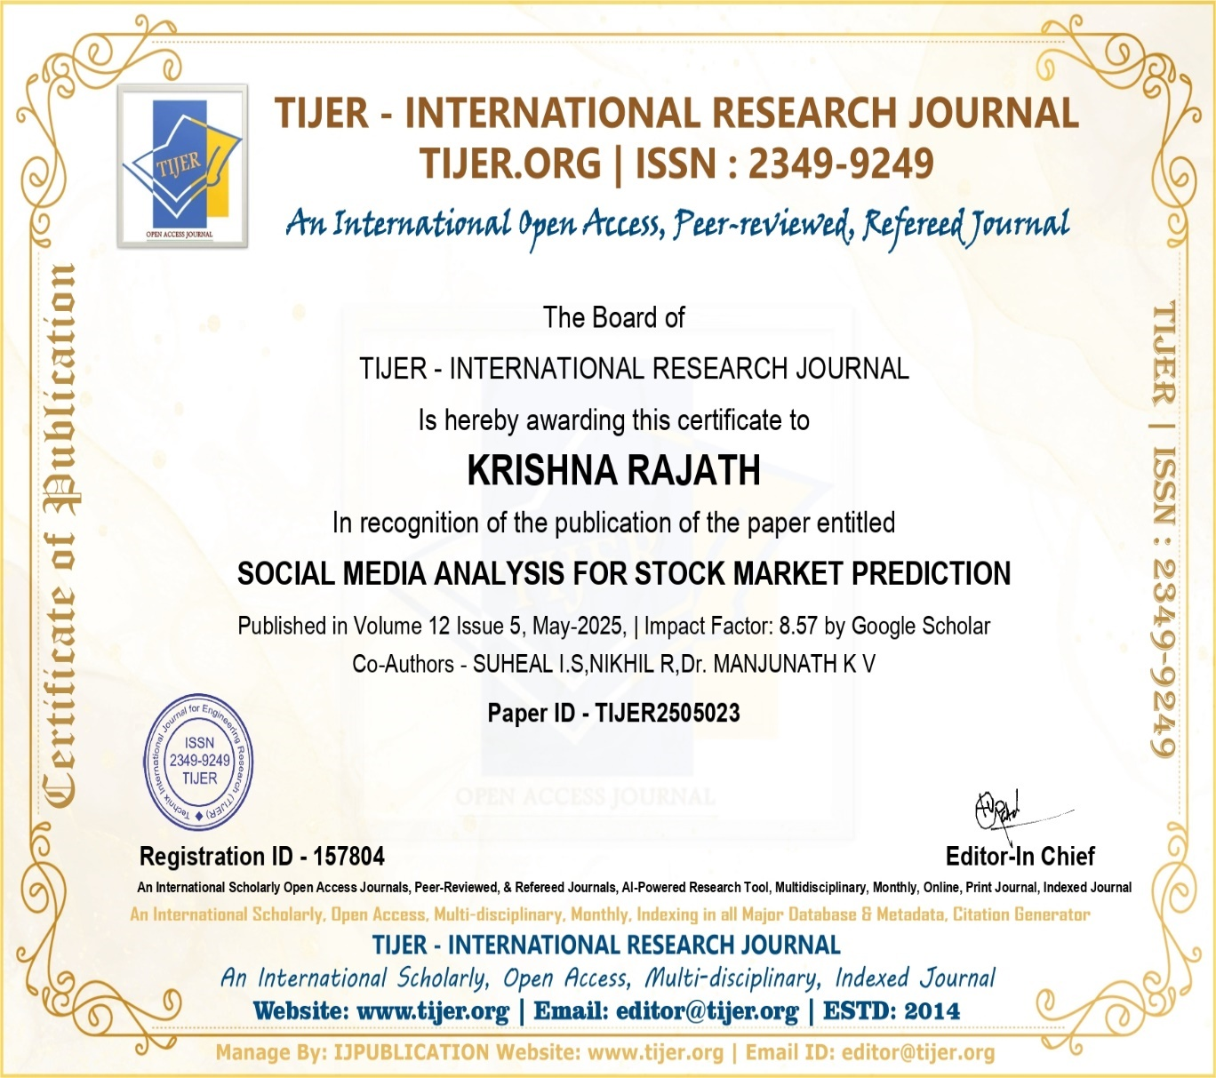





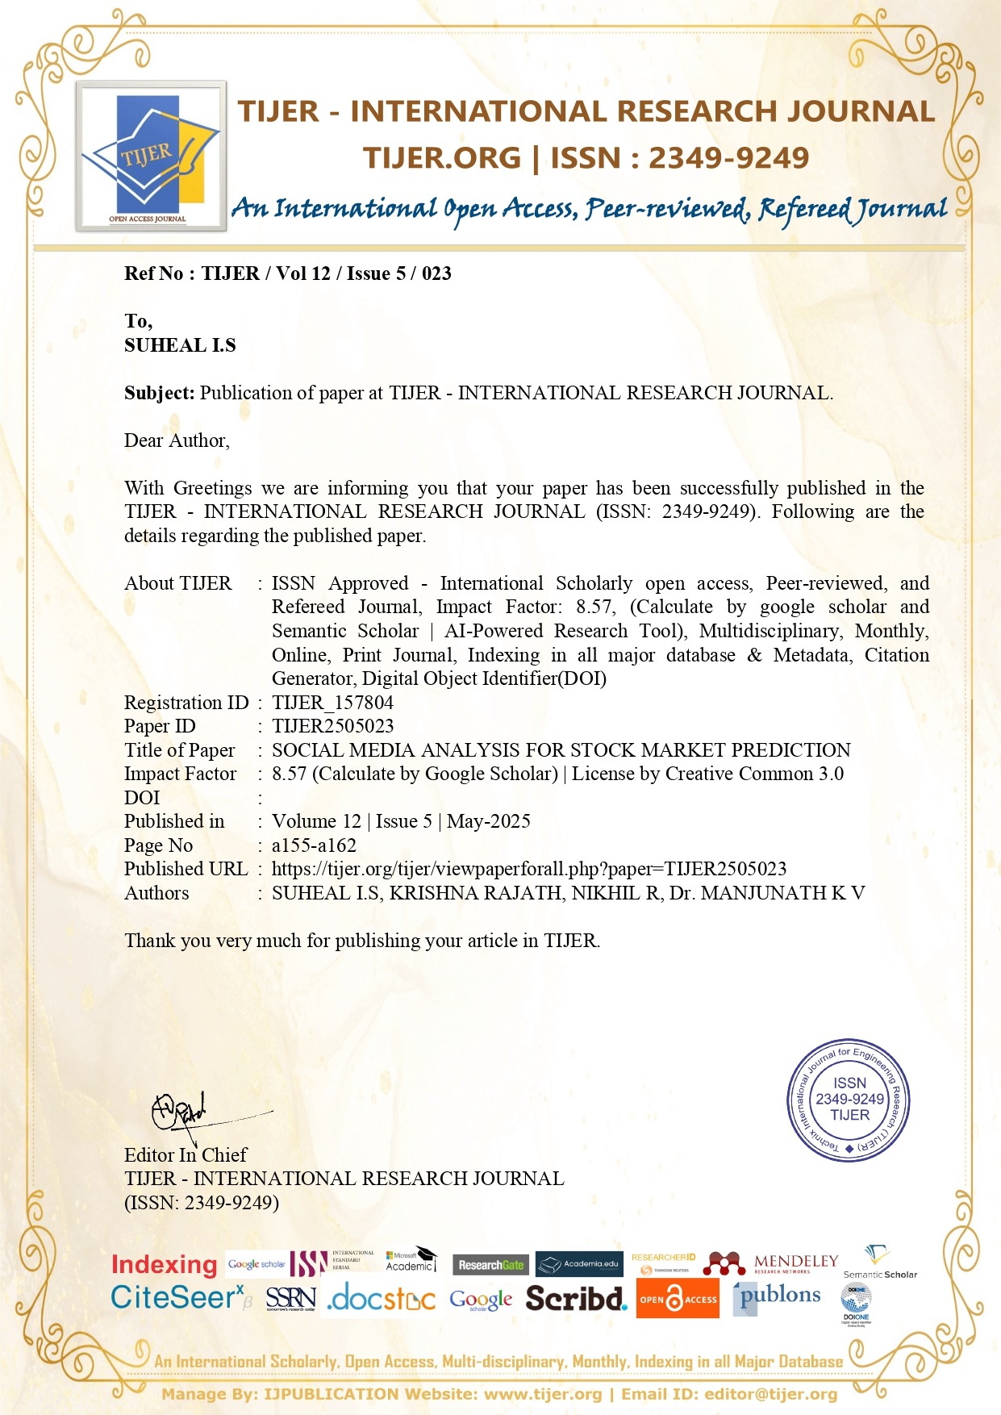

**PLAGARISM REPORT:**

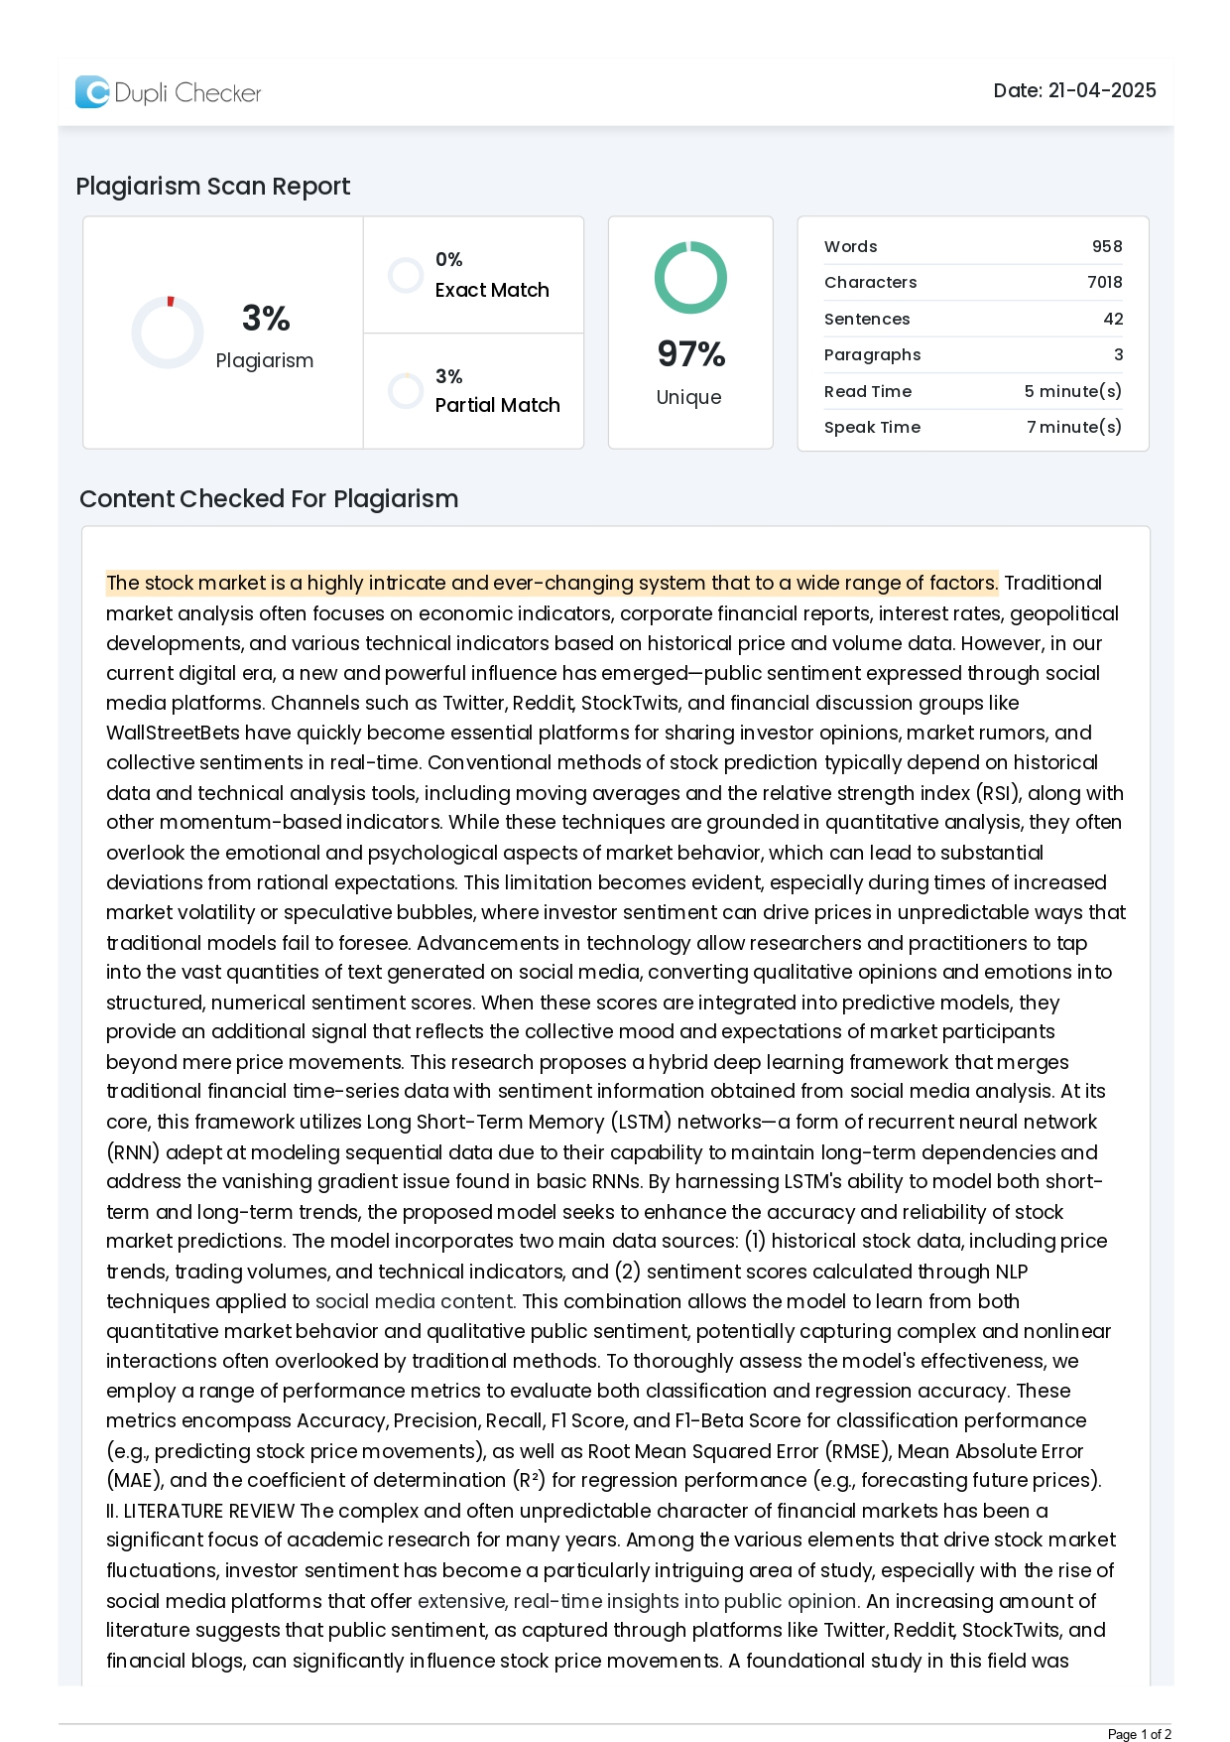

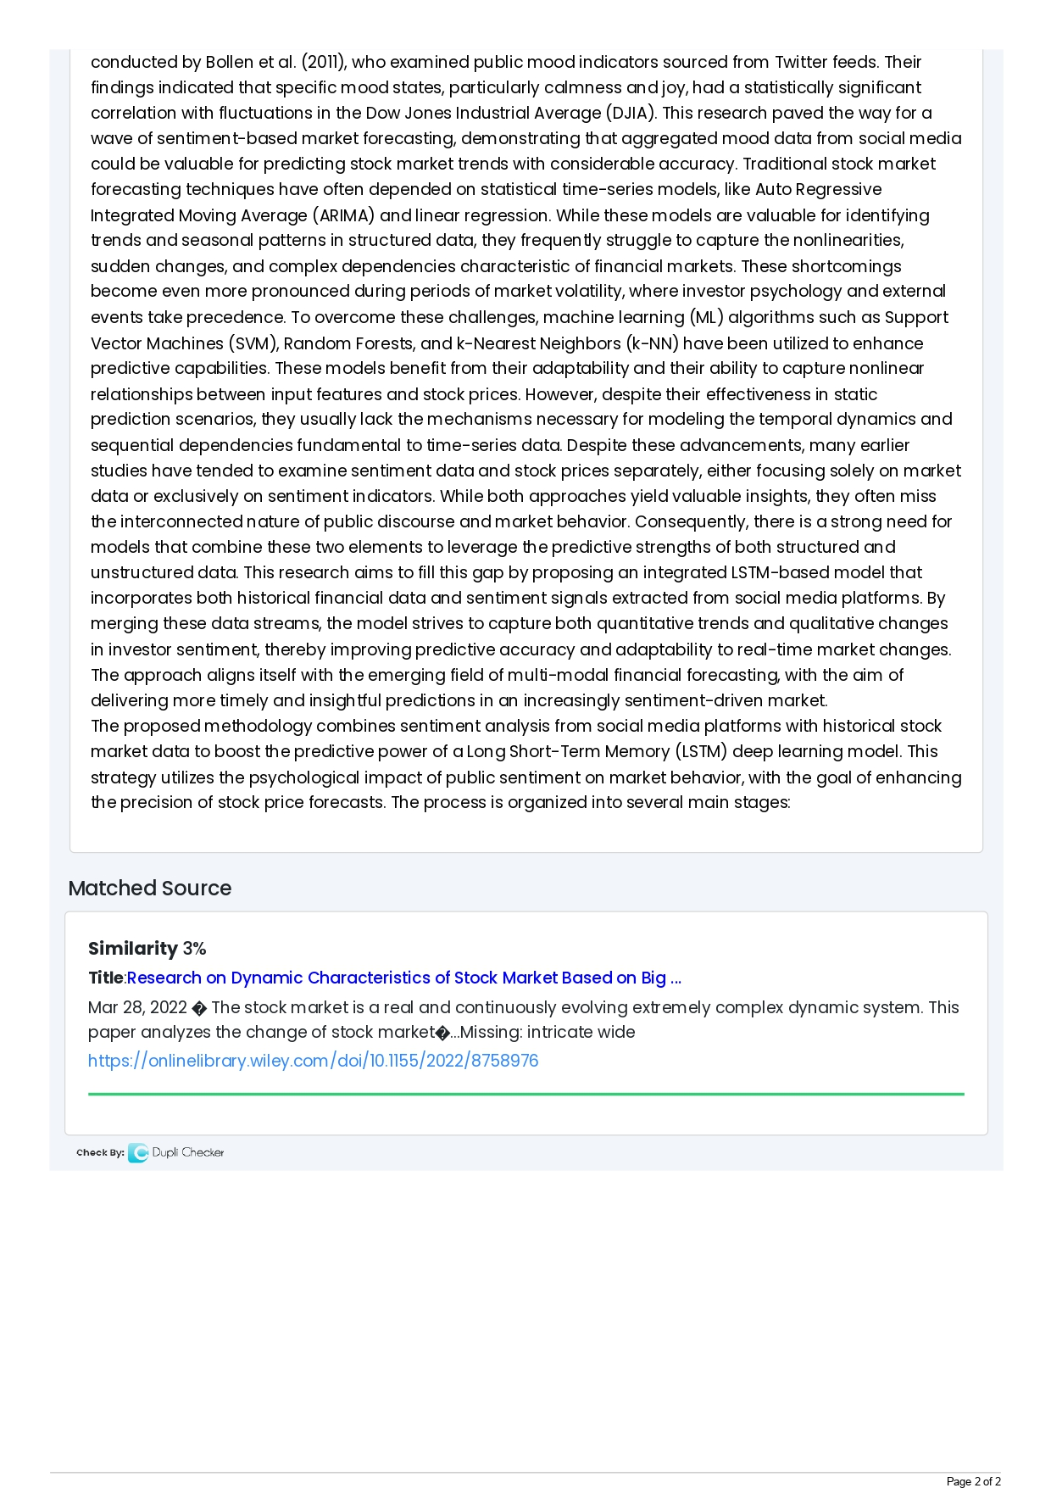

**Published Paper:**

